

Specification

for

Database File Activity

Vicky Harp

11/4/10



Proprietary and Confidential to BBS Technologies, Inc.

© 2006 BBS Technologies, Inc.; all rights reserved.

Revision history:
When? | Who? | What?
11/4/2010 | Vicky Harp | First Draft

Table of Contents
1. Revision history: ii
2. Table of Contents iii
3. Requirements 1
3.1. Overview/Purpose 1
3.1.1. Related Customer Requests 1
3.2. Target Users 1
3.3. Feature/Function Market Requirements 1
3.3.1. Required Functions 1
3.3.2. Non-Supported Functions 1
3.4. FAQ 1
3.5. Open Issues 1
4. Functional Design 2
4.1. User Interfaces 2
4.2. Installation and Upgrade 2
4.3. Permissions and other Required Configuration 2
4.4. Licensing Issues 2
4.5. Dependencies 2
4.5.1. Dependencies on Idera Software 2
4.5.2. Third-Party Software Required on the Customer Machine 2
4.5.3. Third-Party Software Required Internally 2
5. Internal Design 3
5.1. Architecture 3
5.2. Installation Issues 3
5.3. Schedule 3
5.3.1. Work Breakdown and Sizings 3
5.3.2. Areas of Risk 3
6. Quality Assurance Considerations 4
6.1.1. Overview 4
6.1.2. Developer-Created Unit Tests 4
7. Documentation Considerations 4
8. Bibliography 4

Requirements

Overview/Purpose
Customers have expressed an interest in viewing disk activity at the database file level. In SQLdm we currently collect a number of database-level disk metrics which are used solely for reporting and not well exposed in the desktop client. By adding a new view we will be able to tie together two disparate areas of the product – Database Files and Resources…Disks – and provide value to the customer by providing a simple visualization of IO hotspots in their environment.

Related Customer Requests

Target Users
This is intended to be a straightforward view which will provide value to most users of SQLdm.

Feature/Function Market Requirements

Required Functions
- Indicate which data and log files are located on which physical disks
- Indicate which files are involved in IO operations and what kind (read or write)
- Show the recent trend of IO activity for each database file
- Highlight the busiest SQL file on any given disk
- Allow the user to control the amount of data being shown
  - Expand all
  - Collapse all
  - Expand all for one database
  - Show/Hide disk drives
- Operate seamlessly for configured mount points

Non-Supported Functions
- The view will only highlight SQL files currently attached to the selected monitored SQL Server instance. Detached files and those attached to other SQL Server instances will be grouped in with all other non-SQL files in “Other Files.”

FAQ

Open Issues
- The name of this feature is open for discussion. Possible names:
  - Database File Activity
  - Disk Activity
  - File Activity
  - Others?
- In the case of a single drive or a pair of drives, do we want the view to show two columns of files per silo in order to better use the horizontal space?
- Is it necessary to show any disk-level metrics on this view?
- Is it necessary to show IO stall time on this view?

Functional Design

User Interfaces
A new “Database File Activity” view will be added. It will be accessible through context menu from the Disks and Database Files views and will appear in the tree both under Resources and under each individual database. For clarity’s sake, IO activity will be the only metric displayed in this view: no other metrics, including size and wait data, will be displayed.
The view will show each monitored disk drive and mount point as a silo containing rectangular representations of the database files located on that resource.
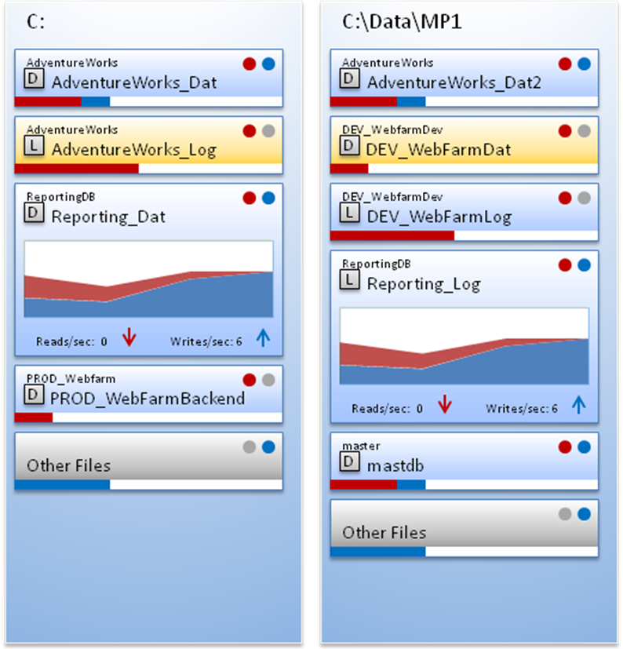
The files will stack into disk silos. Each silo may scroll vertically, and if there are more silos than can be shown on the view, the view will scroll horizontally. Files and disks will be displayed alphabetically (not shown in example) so that the files do not jump around when moving through the history browser. Each file will have two states, expanded and collapsed, which will include different amounts of data.
Though not shown in the screenshot, an indicator will be provided to show the generalized IO activity on each disk.

Expanded File | Collapsed File
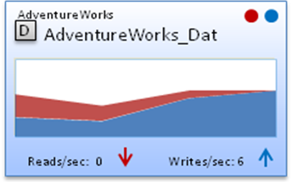 | 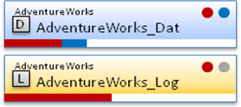
- Database name  - Logical file name  - File type icon  - Read/Write activity lights – these will flash to show file activity  - Recent activity trend – this chart will obey the timeframe specified in the view options for the client  - Current activity/sec labels  - Recent trend arrows based on the last two collections  - A tooltip on the file name will show the full name and data path, while a tooltip on the read and write activity lights will show the current operations per second. Tooltips on the chart will show timestamps and values. | - Database name  - Logical file name  - File type icon  - Read/Write activity lights – these will flash to show file activity  - Relative I/O chart – shows reads and writes relative to the total activity on the drive  - A tooltip on the file name will show the full name and data path, while a tooltip on the read and write activity lights will show the current operations per second

The files will appear in three colors:
- Blue – normal database and log files
- Orange – the most active file on the disk
- Grey – used to indicate non-SQL files, unless this is the most active group

Clicking on a file will collapse or expand it. A context menu on the file will provide the following functionality:
- Expand/Collapse all files for database
- Expand/Collapse all files
- Navigate to disks view
- Navigate to Database Files view
A filter section (not pictured) will allow filtering by drive, database, file type, file name “like”, and file path “like.” All filters will be inclusion filters. When filtering drives, the filtered drive silos will be hidden. For all other filters the files which are filtered out will be grouped into Other Files. A clear filter button will be provided.
Navigating from the Database Files view or from the tree beneath a particular database will cause the view to be filtered by the source database. When navigating from a particular disk in the Disks view (by clicking in the graph) the view will scroll to put the selected disk in focus but no filter will be applied (open to discussion). When navigating from the tree or ribbon in the Resources section all files will be visible and collapsed.
This view will back-fill from the repository and will support the history browser. When navigating from this view to a Databases view in history mode the standard “this view does not support history browser” message will be shown at the destination view.

Installation and Upgrade
No special considerations.

Permissions and other Required Configuration
No special considerations.

Licensing Issues
No special considerations.

Dependencies
No special considerations.

Internal Design

Architecture

Collection Service
The preponderance of the data used by this view is already collected for the scheduled refresh. A new on-demand probe will be added to support real time refreshes but this is not expected to require a great deal of research.

Management Service
Minor service work will be required in the management service to support calling the new probe.

Repository
A stored procedure will be added to support history browser and backfill functionality for the view.

Installation Issues
No special considerations.

Schedule
Component | Who | Sizing
UI Design | Quentin | 15 days
Service and Backend | Vicky | 4 days
Repository | Vicky | 1 day
Unit and Integration Testing – UI | Quentin | 2 days
Unit and Integration Testing – Backend | Vicky | 1 day
Total |  | 23 days

Areas of Risk
No special considerations

Quality Assurance Considerations

Overview
While most of the main test scenarios probably already exist in the QA lab, I want to highlight the following special situations:
- Large/Small number of database files
- Large/Small number of drives
- Long database names
- Long database file names
- Long mount point names
- Drives with no SQL Server files present

Developer-Created Unit Tests
None

Documentation Considerations
No special considerations at this stage.

Bibliography

